AI LAB EXP – 5a

**BFS ALGORITHM FOR REAL WORLD PROBLEMS**

**Tejas Ashok**

**RA1911030010090**

**AIM**

To implement Best First Algorithm using python.

**ALGORITHM**

* Define a list, OPEN, consisting solely of a single node, the start node, s.
* IF the list is empty, return failure.
* Remove from the list the node n with the best score (the node where f is the minimum), and move it to a list, CLOSED.
* Expand node n.
* IF any successor to n is the goal node, return success and the solution (by tracing the path from the goal node to s).
* FOR each successor node:
  1. Apply the evaluation function, f, to the node.
  2. IF the node has not been in either list, add it to OPEN.
* Looping structure by sending the algorithm back to the second step.

**CODE**

from queue import PriorityQueue

v = 14

graph = [[] for i in range(v)]

def best_first_search(source, target, n):

visited = [0] * n

visited[0] = True

pq = PriorityQueue()

pq.put((0, source))

while pq.empty() == False:

u = pq.get()[1]

print(u, end=" ")

if u == target:

break

for v, c in graph[u]:

if visited[v] == False:

visited[v] = True

pq.put((c, v))

print()

def addedge(x, y, cost):

graph[x].append((y, cost))

graph[y].append((x, cost))

addedge(0, 1, 3)

addedge(0, 2, 6)

addedge(0, 3, 5)

addedge(1, 4, 9)

addedge(1, 5, 8)

addedge(2, 6, 12)

addedge(2, 7, 14)

addedge(3, 8, 7)

addedge(8, 9, 5)

addedge(8, 10, 6)

addedge(9, 11, 1)

addedge(9, 12, 10)

addedge(9, 13, 2)

source = 0

target = 9

best_first_search(source, target, v)

**OUTPUT**

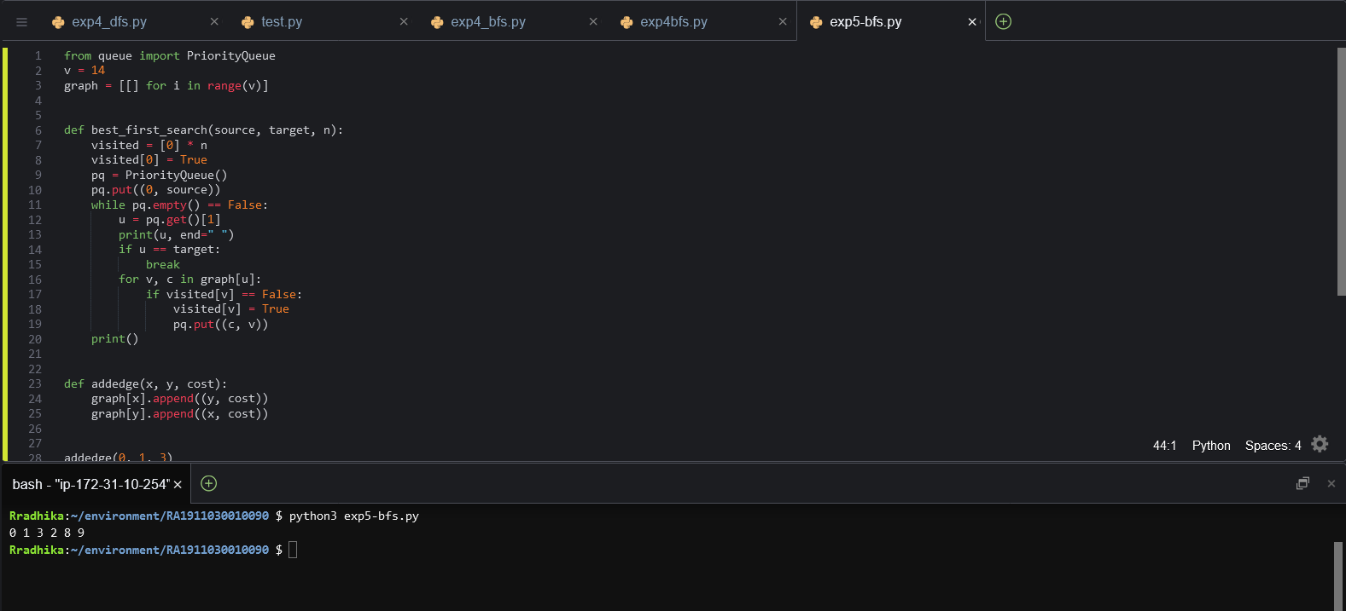

**RESULT**

Best first search algorithm was successfully executed in python.